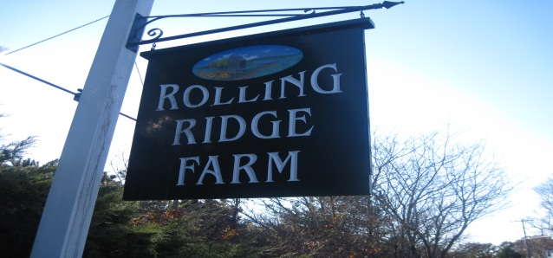
Rolling Ridge Farm Homeowner’s Association
December, 2011 Newsletter
Greetings from the newly elected board of RRFHOA. We hope that this newsletter finds everyone well and not too hectic with last minute holiday preparations! In this letter, we would like to introduce ourselves, update all of our neighbors on the outcome of the annual meeting, and outline our goals for this coming year.
New Board 2011-2012
- Jon O’Neil, President
- Julie Steen, 1st Vice President
- Jim Dever, 2nd Vice President
- Paul Pronovost, Secretary
- Joe Vatelle, Treasurer
Annual meeting held on November 12, 2011
During the second week of November, the annual RRHOA breakfast was held at the Daniel Webster Inn. The current board at that time was Jim Towey, Don Digiacomo, Joe Vatelle, Paul Pronovost, and Jim Carter.
The following is a quick summary of the minutes during the annual meeting. For a complete copy of the minutes, please contact one of us and we will be happy to send one out.
- During the President’s report, Jim Towey reported that the association remains financially strong and legally viable. The covenant project remains at land court pending action by the court. Our existing covenants are valid and remain in place until they complete their action.
- Highlights of the last year include: new active involvement by 3-5 new member families, a successful summer picnic with about 20 families involved, pond renovations (fence and sign repair, dock upgrade, razing of a hazardous shed. Also, landscape and beautification projects included enhanced maintenance of Rolling Ridge entrances, and four poor condition signposts were replaced.
- Some topics that were brought up in the meeting that RRHOA will need to take action on include: how to deal with vandals spraying signposts and defacing the tennis courts, beach renourishment, poor communication among neighbors and new families entering the association, condition of the hiking trails, solar panel protocol, and that covenants should be made more available.
- The board reported that it hired an accountant, Andrew Miller to take over some of the administrative functions of the association
- Three new members were nominated and voted into office: Julie Steen, Jim Dever, and Jon O’Neil.
RRFHOA Board Meeting, December 7th, 2011
Earlier this month the new board met for the first time to discuss our plan for this upcoming year. There were a few items that we identified a need to be addressed.
- Communication.
As a board, we feel that the association can greatly improve communication in the neighborhood. Jon O’Neil is in the processing of getting the information needed to update the association website. Our hope is to keep this updated on a regular basis and to keep necessary forms and covenants in an area where they are easy to access and download. We have also made a Rolling Ridge Homeowners Association group on Facebook. We are also hoping to gather a database with everyone’s email address to send newsletters and updates out electronically. This will help the association save costs and is environmentally friendlier.

Please email Julie Steen at: jsteen67@yahoo.com to let us know if you would prefer your newsletter electronically or if you would prefer a paper copy sent out to you. If you would like to receive paper copies, please include your mailing address. If you do not have access to email, please call one of the board members and let them know that you would like to have correspondence sent to your mailing address.

- Committees

When we sat down as the new board, we all had our own “mini list” if you will, of the things in the association that we would like to improve. Many of the ideas we had in common were pretty basic and we are making the assumption that the 5 of us are not alone in our opinions.
To accomplish all that we would like to as a neighborhood, we need to get everyone involved. We came up with three committees that we would like to see started. Each committee will be able to use RRHOA funds to complete their mission with board approval. The chairs of each committee will be encouraged to participate in the monthly board meeting.

Hospitality/Welcoming Committee: This will be a committee that welcomes new neighbors to the association. Other duties may include putting together dinners for families in need due to sickness, new child or other circumstances. We need someone willing to run this committee and volunteers to participate.

Trails/Tennis Court Committee: This will be a committee that will head up trail and tennis court maintenance. As we stand now, many of the trails are over grown and need to be cut back to be open for use. Also the tennis courts are in need of repair. We are looking for someone willing to run this committee and volunteers to participate.

Beach Committee: This committee will be in charge of maintaining the docks, making sure the gravel road is passable, beach nourishment, and assisting in brainstorming gate/beach key ideas. Again, we need someone willing to run this committee and volunteers to assist.

- The third item that we need to address is to sign off with the new accountant and make sure all of the records that he currently has are updated. This is progressing well and by mid-January, Mr. Miller should have everything up to date. This will ensure that the billing process for annual dues and other invoices progress smoothly.
We want to send out a special Thank You to Joe and Ginny Vatelle, who decorated the Rolling Ridge sign in the spirit of the holiday season. It looks fantastic!!
We are looking forward to hearing from everyone and greatly appreciate any feedback and ideas you may have to improve our wonderful association.
Please make sure you:
1. Email jsteen67@yahoo.com with an email address where you would like to receive your RRFHOA newsletters and updates .
2. If you are on Facebook, please feel free to join the Rolling Ridge group.
3. Please consider chairing, co-chairing or volunteering for any of the three committees listed.
Feel free to email any one of us with your questions and or concerns.
Sincerely,

Julie Steen
Contact information:
Joe O’Neil: joneil@comcast.net
Julie Steen: jsteen67@yahoo.com
Jim Dever: jamesjdever71@yahoo.com
Paul Pronovost: paulernest@comcast.net
Joe Vatelle: joeandginny@comcast.net

